Spend wise

Project overview:

- Purpose

Spendwise is a personal finance management app to track expenses, income, and savings.
- Key Features:
- Expense tracking
- Income management
- Budgeting
- Savings goals
- Target Audience: Individuals looking to manage finances effectively

1. Introduction :
SpendWise is a personal finance and expense-tracking application designed to help users manage their daily spending, track budgets, and analyze financial habits. The system allows users to record expenses, categorize transactions, and generate reports to understand spending patterns.

The main objective of the SpendWise system is to provide a simple and efficient way for individuals to control their finances and make informed budgeting decisions.

2. Problem Statement :
Many people struggle to track their expenses and manage their budgets effectively. Manual tracking is time-consuming and often inaccurate.

SpendWise solves this problem by:

Automatically organizing transactions

Providing spending insights

Generating visual reports and statistics.

3. Objectives :
The main objectives of the SpendWise project are:

To help users track daily expenses.

To categorize spending automatically.

To generate financial reports and analytics.

To allow users to set and monitor budgets.

To visualize spending patterns for better decision-making.

4. System Overview
SpendWise is an expense-management system that allows users to:

Record income and expenses.

Categorize transactions.

Track monthly spending.

Generate reports and analytics.

The system stores financial data securely and provides tools for managing personal finances effectively.

5. Features :
Key features of the SpendWise system include:

1. Expense Tracking
Users can add and manage daily expenses and income records.

2. Categorization
Transactions are automatically categorized (e.g., Food, Travel, Shopping).

3. Budget Management
Users can set monthly budgets and track spending against them.

4. Reports and Analytics
Visual charts and reports help users analyze spending patterns.

5. Transaction Management :
Users can edit, delete, and search transactions easily.

6. Data Visualization :
Graphs and dashboards show spending insights and financial statistics.

7. System Architecture :
The SpendWise system typically follows a three-tier architecture:

Presentation Layer

User interface

Displays financial data and charts

Application Layer

Handles business logic

Processes transactions and budgets

Database Layer

Stores user data, transactions, and categories

8. Technology Stack :
Example technologies used in the SpendWise project:

Component Technology
Frontend HTML, CSS, JavaScript
Backend Python / Node.js / Java
Database SQLite / MySQL
Visualization Charts / Graph libraries
Some implementations also use Python with SQLite for secure local data storage.

9. Modules :
1. User Module
User registration

Login authentication

Profile management

2. Expense Module
Add expenses

Categorize transactions

View expense history

3. Budget Module
Set monthly budgets

Track spending limits

4. Reports Module
Monthly reports

Category-wise spending

Financial insights

10. Database Design :
Typical tables in SpendWise include:

Users Table
User ID

Name

Email

Password

Transactions Table
Transaction ID

Date

Category

Amount

Description

Categories Table
Category ID

Category Name

11. Advantages :
Easy expense tracking

Better financial planning

Real-time spending analysis

Improved budgeting habits

12. Future Enhancements :
Possible improvements for the SpendWise system:

Mobile app integration

Bank API integration

AI-based spending analysis

SMS transaction detection

Fraud alerts.

13. Conclusion:
SpendWise provides an efficient solution for managing personal finances. The system enables users to monitor their expenses, set budgets, and analyze spending behavior through reports and visualizations. This helps users develop better financial discipline and achieve financial stability.

Demo :
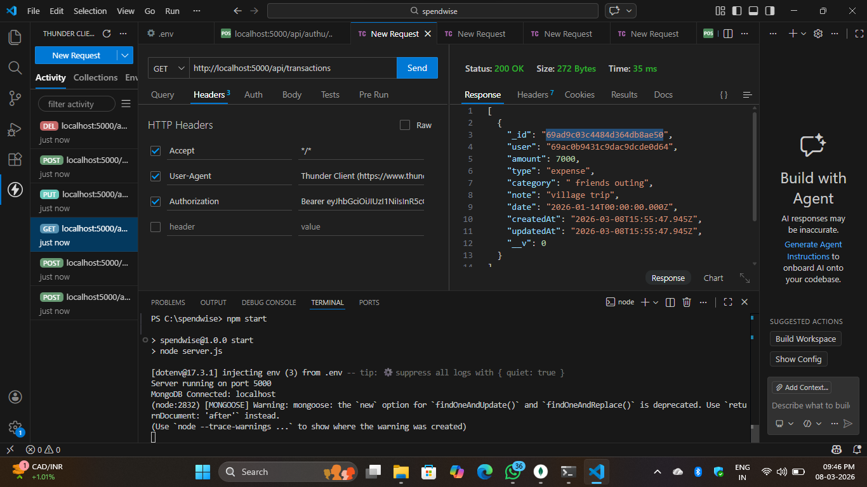
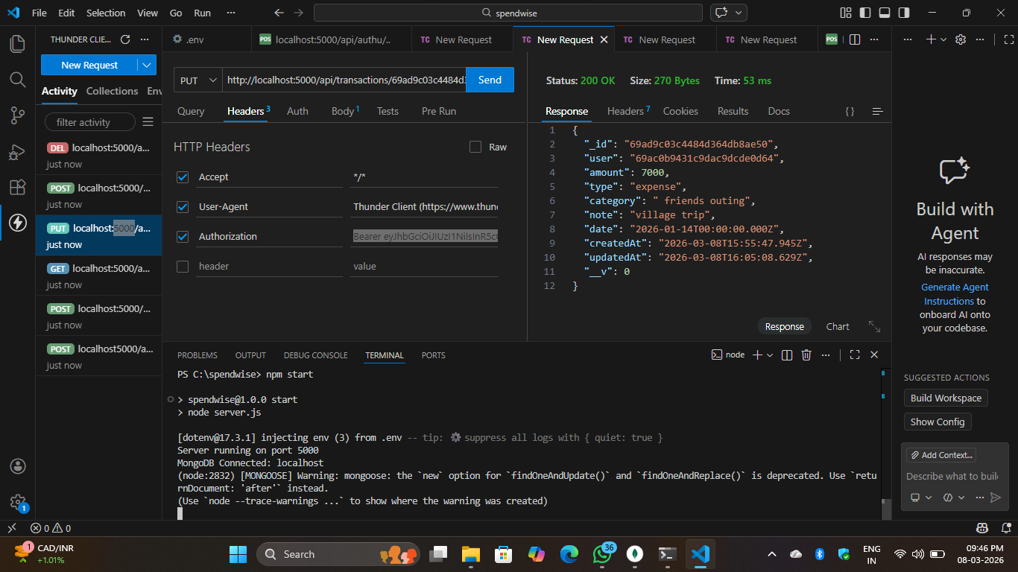
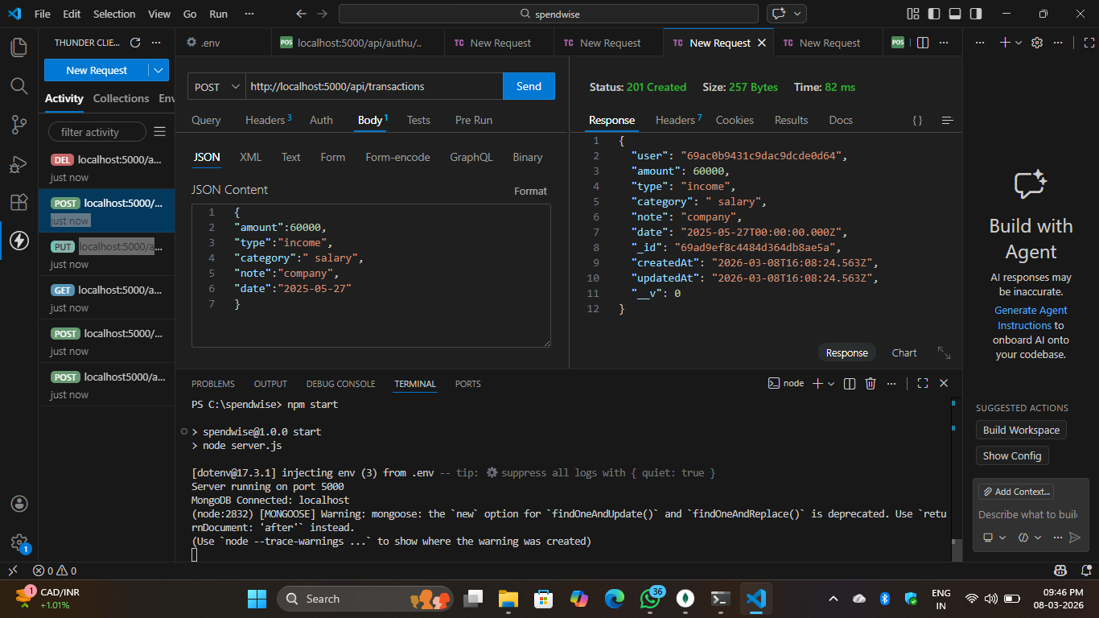

Mongo db compass :
